school management system

**Project Description**:

Project Description: The school management system is a REST API-based tool used to manage school records such as student details, grades, teacher details, and leaves of teachers and students.

**Project Objectives:**

The objective of the school management system is to organize the student’s data and teachers’ data. Admin can add student details and students’ grades and Admin can add teachers’ details .students can request leaves which will be approved or rejected by the admin. teachers can request leaves that will be approved or rejected by the admin.Admin can perform operations on students’ and teachers’ records like search, update, and delete. The students and teachers will be notified by text message to their Mobile at the time of leave request and also after the status update by the admin.

**Project Scope:**

In every school, there will be many numbers of students and teachers without a proper system we can not organize the data of all students and teachers which consumes more time if we want to retrieve, add, delete and search, any student and teacher. the teacher or students can easily request leave and it can be monitored by the admin.

The school management system can be used in any school based on their requirement.

**ER diagram :**

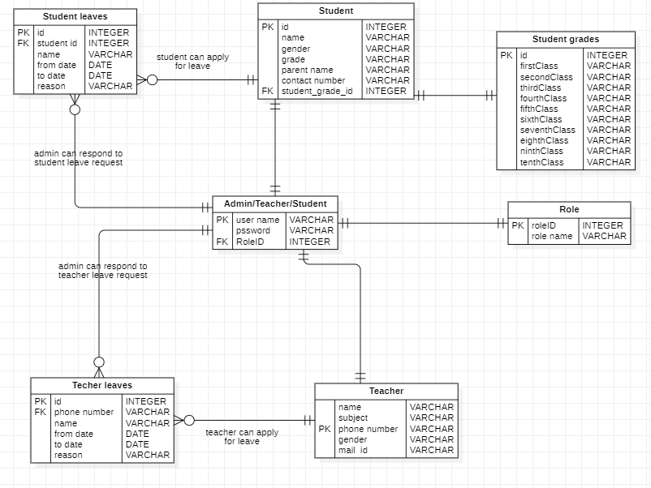

**Usecase diagram :**

**Functional Requirements:**

**1. Admin**

* **Add students:** admin can add students along with their details and grades.
* **Search student:** admin can search student’s details by student ID number if the student ID is valid.
* **Delete student:** admin can delete student records by student ID if the student ID is valid.
* **Update student:** admin can update student record
* **List of Students:** admin can get all student’s records.
* **Add Teacher:** admin can add teachers along with their details.
* **Search teacher:** admin can search teacher details by teacher phone number if the teacher’s phone number is valid.
* **Delete teacher:** admin can delete teacher records by teacher phone number if a student-teacher phone number is valid.
* **Update teacher:** admin can update teacher record.
* **List of teachers:** admin can get all teacher records.
* **View leave requests from teachers and students:** admin can see all new leave requests.
* **View all old leave requests from teachers and students:** admin can see all old and new leave requests.
* **Responding to leave requests:** admin can approve/deny leave requests.
* **Sending a message to all teachers:** admin can send a message to all teachers
* **Sending a message to all students:** admin can send a message to all students
* **Sending a message to all teachers and students:** admin can send a message to all teachers and students.

**2. Teacher**

* **Leave request:** teacher can request leave.
* **Request status:** teacher can see the status of leave requests and also old requests.

**3. Student**

* **Leave request:** Students can request leave.
* **Request status:** Students can see the status of leave requests and also old requests.

## **Technical Requirements**

* Backend – Java Spring Boot
* Database – MYSQL
* ORM – Hibernate
* Language – Java
* API Testing – Postman or Chrome plug-in.